蓝科实业有限公司

地址：深圳市龙华新区民治大道展韬科技大厦A906
产品订购单

生产商：深圳市科易互动机器人有限公司
联系人:谷小姐
电话：0755-23760972
传真：
OS201607013
2016/8/29
陈先生/杨小姐
13642843345

我司编号

ME058

ME125

ME128

ME132

ME134

ST1080

ST1107
工厂编号

MD0116

MD0029

MD0105

MD0183

MD0209

KY0019

KY0046
照片
描述

1A Lithium battery charging board

5v stepping motor with ULN2003
driver board

LM2577 DC voltage boost moudle

DC-DC boost/(0.9v-5v) module
600ma-usb 5v

DC-DC adjustable Voltage
power module LM2596S

Arduino compatible 5V Relay
Module

Arduino compatible photosensitive
sensor moudle with 3 pin flatcable
数量

100

400

400

100

400

200

400
价格

¥4.80

¥7.00

¥16.00

¥4.40

¥4.40

¥3.50

¥4.50
吸塑费用

¥0.80

¥0.80

¥0.80

¥0.80

¥0.80

¥0.80

¥0.80
单价

¥5.60

¥7.80

¥16.80

¥5.20

¥5.20

¥4.30

¥5.30
金额

¥560.00

¥3,120.00

¥6,720.00

¥520.00

¥2,080.00

¥860.00

¥2,120.00
客人编号

VMA321

VMA401

VMA402

VMA403

VMA404

VMA406

VMA407
订单号

1006276

1006280

1006282

1006284

1006286

1006290

1006292
备注

吸塑包装
2个吸塑一起

吸塑包装

吸塑包装

吸塑包装
2个吸塑一起

吸塑包装

吸塑包装

吸塑包装
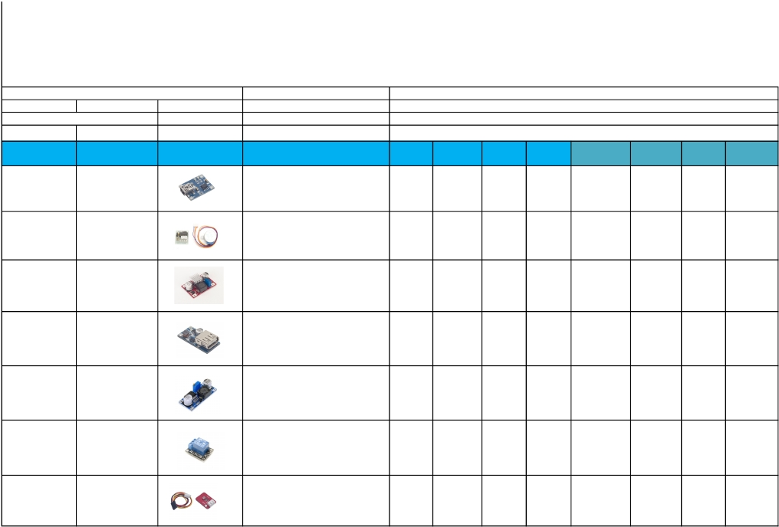

ST1112 | EB0018 |  | L298N dual bridge DC steppercontroller board | 400 | ¥13.00 | ¥0.80 | ¥13.80 | ¥5,520.00 | VMA409 | 1006296 | 吸塑包装
ST1167 | MD0237 |  | 3.3V/5V TTL logic level convertboard | 200 | ¥2.30 | ¥0.80 | ¥3.10 | ¥620.00 | VMA410 | 1006298 | 吸塑包装
ST1168 | MD0180 |  | Arduino compatible MOS drivingmoudle | 400 | ¥6.00 | ¥0.80 | ¥6.80 | ¥2,720.00 | VMA411 | 1006300 | 吸塑包装
AC048 | OR0008 |  | 40pins 30cm plug to plugjumper wire(flatcable) | 400 | ¥3.80 | ¥0.80 | ¥4.60 | ¥1,840.00 | VMA413 | 1006304 | 吸塑包装
AC050 | OR0010 |  | 40pins 30cm female to femalejumper wire(flatcable) | 400 | ¥3.30 | ¥0.80 | ¥4.10 | ¥1,640.00 | VMA415 | 1006308 | 吸塑包装
AC060 | AC060 |  | Atmega328P MCU ic with arduinouno bootloader and 16MHZ crystal | 80 | ¥8.50 | ¥0.80 | ¥9.30 | ¥744.00 | VMA416 | 1006312 | 吸塑包装Atmega328P(刷带兼容arduinoUnobootloade
ST1046 | MD0227 |  | Arduino compatible data loggingshield | 400 | ¥16.00 | 0.8 | ¥16.80 | ¥6,720.00 | VMA202 | 1006216 | 吸塑包装
ST1113 | EB0012 |  | Keypad shield for arduino-LCD1602 | 400 | ¥12.00 | 0.8 | ¥12.80 | ¥5,120.00 | VMA203 | 1006220 | 吸塑包装
ME048 | MD0096 |  | S1302 real-time clock moudle/withbattery CR2023 | 200 | ¥6.00 | 0.8 | ¥6.80 | ¥1,360.00 | VMA301 | 1006232 | 吸塑包装2个吸塑一起
ME110+SE045 | MD0021+KY0059 |  | Arduino compatible soil moisturesensor+ water sensor moudle | 200 | ¥6.40 | 0.8 | ¥7.20 | ¥1,440.00 | VMA303 | 1006236 | 吸塑包装2款产品吸塑一起
ME130 | MD0141 |  | Capacitive touch sensor switch | 400 | ¥6.00 | 0.8 | ¥6.80 | ¥2,720.00 | VMA305 | 1006240 | 吸塑包装

ME140 |  |  | HC-SR05 ultrasonic sensor | 400 | ¥5.60 | 0.8 | ¥6.40 | ¥2,560.00 | VMA306 | 1006242 | 吸塑包装
SE043 | KY0004 |  | Arduino compatible key switchsensor moudle | 100 | ¥5.60 | 0.8 | ¥6.40 | ¥640.00 | VMA310 | 1006250 | 吸塑包装2个吸塑一起
SE054 | KY0003 |  | Arduino compatible holzer(hall)magneticswitch moudle | 100 | ¥5.00 | 0.8 | ¥5.80 | ¥580.00 | VMA313 | 1006256 | 吸塑包装2个吸塑一起
SE062 | MD0020 |  | Pir motion sensor for arduino | 400 | ¥4.70 | 0.8 | ¥5.50 | ¥2,200.00 | VMA314 | 1006258 | 吸塑包装
ST1079 | KY0023 |  | XY joystick moudle | 100 | ¥7.60 | 0.8 | ¥8.40 | ¥840.00 | VMA315 | 1006262 | 吸塑包装2个吸塑一起
ST1143 | KY0012 |  | Arduino compatible active buzzermoudle | 100 | ¥5.60 | 0.8 | ¥6.40 | ¥640.00 | VMA319 | 1006270 | 吸塑包装2个吸塑一起
ME113 | MD0007 |  | 4-channel relay moudles | 400 | ¥13.00 | 0.8 | ¥13.80 | ¥5,520.00 | VMA400 | 1006278 | 吸塑包装
ME138 | OR0097 |  | RC522 RFID IC set for aruino | 400 | ¥14.70 | 0.8 | ¥15.50 | ¥6,200.00 | VMA405 | 1006288 | 吸塑包装
ST1109 | EB0042 |  | Super-mini digital amplifer board | 200 | ¥3.30 | 0.8 | ¥4.10 | ¥820.00 | VMA408 | 1006294 | 吸塑包装
AC049 | OR0009 |  | 40pins 30cm male to femalejumper wire (flatcable) | 400 | ¥3.60 | 0.8 | ¥4.40 | ¥1,760.00 | VMA414 | 1006306 | 吸塑包装
CC016 | CR0019 |  | Two -wheel tracing car classis | 160 | ¥37.00 | 0.8 | ¥37.80 | ¥6,048.00 | VMA500 | 1006316 | 礼盒包装

KTS012 | KT0003 |  | Diy-basic starter kit for arduino | 160 | ¥78.00 | 0.8 | ¥78.80 | ¥12,608.00 | VMA501 | 1006320 | 礼盒包装
KTS016 | KT0008 |  | BASIC-KIT FR4+plasticdevelopment boardtool set for arduino | 160 | ¥85.00 | 0.8 | ¥85.80 | ¥13,728.00 | VMA502 | 1006324 | 礼盒包装
KTS021 | KT0021 |  | Electronic parts pack for arduino | 160 | ¥63.00 | 0.8 | ¥63.80 | ¥10,208.00 | VMA503 | 1006326 | 礼盒包装
KTS08 |  |  | Basic arduino compatibleexperimenter's kit | 160 | ¥72.50 | 0.8 | ¥73.30 | ¥11,728.00 | VMA504 | 1006328 | 礼盒包装
ST1025 | MB0019 |  | Arduino uno REv3 compAtiblEboArd | 800 | ¥24.80 | 0.8 | ¥25.60 | ¥20,480.00 | VMA100 | 1006190 | 吸塑包装
ST1026 | MB0014 |  | Arduino compAtiblE 2560 R3 | 240 | ¥43.80 | 0.8 | ¥44.60 | ¥10,704.00 | VMA101 | 1006194 | 吸塑包装
ST1027 | MB0016 |  | Arduino compAtiblE NANO3.0 | 400 | ¥28.00 | 0.8 | ¥28.80 | ¥11,520.00 | VMA102 | 1006202 | 吸塑包装
ST1028 | MB0017 |  | Arduino compAtiblE lEonArdodEvElopmEnt boArd | 400 | ¥26.00 | 0.8 | ¥26.80 | ¥10,720.00 | VMA103 | 1006204 | 吸塑包装
EX023 | EB0051 |  | Arduino compAtiblE ExpAnsionboArd for Arduino uno R3 | 400 | ¥13.00 | 0.8 | ¥13.80 | ¥5,520.00 | VMA200 | 1006208 | 吸塑包装
ST1033 | EB0001 |  | PROTOSHIELD phototyping boArdwith mini brEAdboArd for Arduinouno | 400 | ¥8.50 | 0.8 | ¥9.30 | ¥3,720.00 | VMA201 | 1006214 | 吸塑包装

ME027 | MD0051 |  | 3-AXIS digitAl AccElErAtion sEnsormoudlE- mmA7455 | 400 | ¥8.00 | 0.8 | ¥8.80 | ¥3,520.00 | VMA204 | 1006226 | 吸塑包装
ME043 | MD0089 |  | 3X4 mAtrix kEypAd mEmbrAmEswitch | 200 | ¥3.40 | 0.8 | ¥4.20 | ¥840.00 | VMA300 | 1006228 | 吸塑包装
ME081 | MD0194 |  |  | 400 | ¥21.00 | 0.8 | ¥21.80 | ¥8,720.00 | VMA302 | 1006234 | 吸塑包装
ME126 | MD0043 |  | SD cArd logging shiEld for Arduino | 100 | ¥6.00 | 0.8 | ¥6.80 | ¥680.00 | VMA304 | 1006238 | 吸塑包装2个一起吸塑
SE013 | KY0021 |  | Arduino compAtiblE mini mAgnEticrEEd moudlE | 100 | ¥7.00 | 0.8 | ¥7.80 | ¥780.00 | VMA308 | 1006246 | 吸塑包装2个一起吸塑
SE010 | KY0016 |  | Arduino compAtiblE RGB LEDmoudlE | 100 | ¥5.60 | 0.8 | ¥6.40 | ¥640.00 | VMA307 | 1006244 | 吸塑包装2个一起吸塑
SE019 | KY0030 |  | Arduino compAtiblE microphonEsound sEnsor moudlE | 400 | ¥4.00 | 0.8 | ¥4.80 | ¥1,920.00 | VMA309 | 1006248 | 吸塑包装
SE052 | KY0015 |  | DHT11 digitAl tEmpErAturEhumdity sEnsormoudlE for Aduino | 400 | ¥6.00 | 0.8 | ¥6.80 | ¥2,720.00 | VMA311 | 1006252 | 吸塑包装
SE053 | KY0002 |  | Arduino compAtiblEvibrAtion/shockswtich moudlE | 200 | ¥5.60 | 0.8 | ¥6.40 | ¥1,280.00 | VMA312 | 1006254 | 吸塑包装2个一起吸塑
ST1087 | KY0005 |  | Arduino compAtiblE infrArEdtrAnsmittEr moudlE | 100 | ¥5.00 | 0.8 | ¥5.80 | ¥580.00 | VMA316 | 1006264 | 吸塑包装2个一起吸塑
ST1089 | KY0022 |  | Arduino compAtiblE 1838 IRinfrArEd37.9KHZ rEcEivEr | 100 | ¥5.60 | 0.8 | ¥6.40 | ¥640.00 | VMA317 | 1006266 | 吸塑包装2个一起吸塑

ST1090 | KY0009 |  | Arduino compAtiblE 3-colorRGB SMD LED moudlE | 100 | ¥5.00 | 0.8 | ¥5.80 | ¥580.00 | VMA318 | 1006268 | 吸塑包装2个一起吸塑
ST1147 | KY0013 |  | Arduino compAtiblE AnAlogtEmpErAturE sEnsor moudlE | 100 | ¥5.60 | 0.8 | ¥6.40 | ¥640.00 | VMA320 | 1006272 | 吸塑包装2个一起吸塑
 |  |  |  |  |  |  |  | ¥208,708.00
备注：1.所有产品的材料均为环保材料，PCB板为白色，丝印蓝色字体。
2.大货生产必须按照Vellemanda的丝印和 ROHS要求生产
下单日期 | 2016/8/29
交货日期: | 2016/9/
※备注说明:
1. 外箱正唛：(贴2面）
Front Mark : VEL
OrderNo.: 1006276 → （如:1006276，1006280 …….)
C/No.:
2. 外箱侧唛：(贴2面）
PartNo.: VMA321 →（如:VMA321 ，VMA401……)
Qty.:
G.W.:
N.W.:
Means.:
3. 贴纸内容 (每款产品贴上PO#）
*质量要求：请确保产品质量，严格按照确认样品生产,若发生质量问题,客户对此提出索赔，则生产厂家需要承担一切责任。
*包装要求：产品包装不得涉及专利；外箱不得贴改，厚度至少5层瓦楞，打4条包装带成“#”字型。
*包装上或产品里面不得出现生产厂家网站、联系方式、产品目录、广告画册等资料.
*交货期:订单一经确定,供方须准时交货,如不能按时交货提前通知我司,同时因逾期交货而造成的损失应由供方全部负责.
*如产品包装尺寸,毛净,装箱量等与放样品时有所改动,请务必在接单后生产前及时通知我司,我司对此保有权利修改订单.
*付款方式：出货后 30 天。
*接到定单后有何问题须在2天内联系我司,否则请遵照我司要求生产.在生产时，务必遵照合约要求，否则买方有权取消订单.
生产商签名:
接单时间：

